**Spesifikasi Kemasan**

**Nama Produk :** ZOI Ilios 5000 Series Surgical Light - Single Dome Mobile Type

**Tipe :** ZOI-SL-IL-5100M

1. **Label**
   1. Label penandaan ZOI Ilios 5000 Series Surgical Light - Single Dome Mobile Type

* Bahan : Stiker Vinyl
* Warna Label : Putih
* Warna Teks : Hitam
* Ukuran : 90 x 60 mm (p x l)

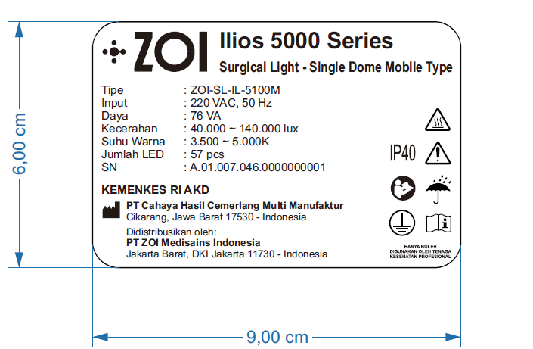

Gambar 1. Label Penandaan ZOI Ilios 5000 Series Surgical Light - Single Dome Mobile Type

1. **Kemasan**
   1. Wooden Box ZOI Ilios 5000 Series Surgical Light - Single Dome Mobile Type
      * Bahan : Kayu
      * Bentuk : Kotak
      * Warna : Natural/kayu/Coklat
      * Ukuran : 115 x 115 x 65 cm (p x l x t)

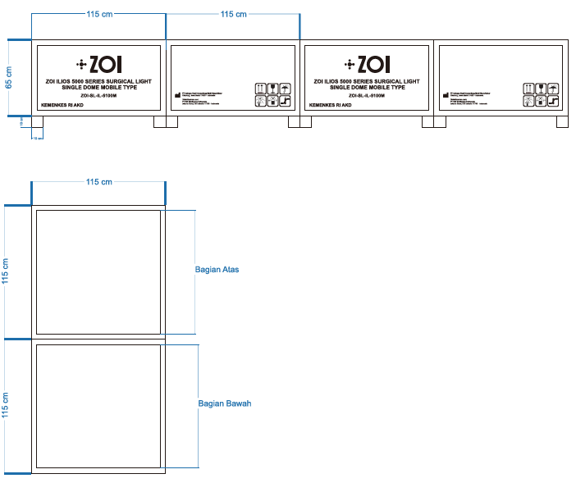

Gambar 2. Wooden Box ZOI Ilios 5000 Series Surgical Light - Single Dome Mobile Type

* 1. Corrugated Box Head Lamp ZOI Ilios 5000 Series Surgical Light - Single Dome Mobile Type
     + Bahan : Corrugated
     + Bentuk : Kotak
     + Warna : Coklat
     + Ukuran : 105 x 100 x 25 cm (p x l x t)

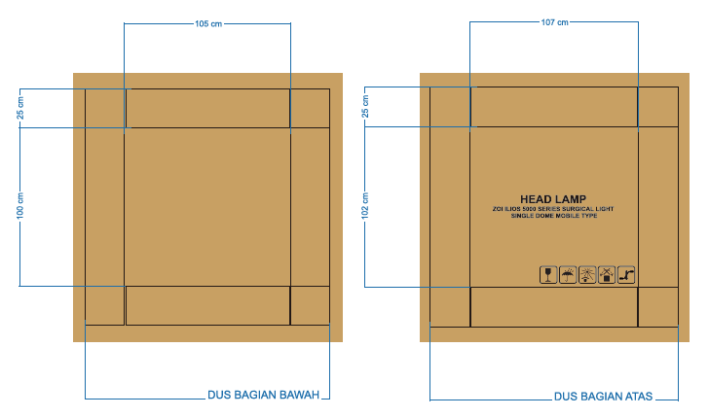

Gambar 3. Corrugated Box Head Lamp ZOI Ilios 5000 Series Surgical Light - Single Dome Mobile Type